Smart Contract Security Audit

|  |  |  |
| --- | --- | --- |
| **Smart Contract** | **Audited by** | **Dated** |
| Mr.Mint | Esp Softtech | 05/05/2022 |

**Table of Contents**

### Background 3

1. **Project Information** 3 Smart Contract Information

Executive Summary

1. **File and Function Level Report** 5

File in Scope

1. **Issues Checking Status** 7 Severity Definition

Audit Findings

1. **Automatic Testing** 11 Testing proves

Inheritance graph Call graph

1. **Unified Modeling Language (UML)** 14
2. **Functions Signature** 15
3. **Automatic General Report** 16
4. **Conclusion** 18
5. **Disclaimer** 19

Background

The purpose of the audit was to achieve the following:

* + Ensure that the smart contract functions as intended.
  + Identify potential security issues with the smart contract.

The information in this report should be used to understand the risk exposure of the smart contract, and as a guide to improve the security posture of the smart contract by remediating the issues that were identified.

Project Information

* **Platform**: Binance Smart Chain
* **Contract Address**: 0xcbb352de4241f3967c281e81446d72942f50e0f0
* **MR. MINT Smart Contract**: MR. MINT Binance smart chain-based

Binance verified audited contract enables the use of Binance Coin BEP-20 for use in investment industry. The Longevity and stability of MR. MINT will ultimately bring crypto users, miners, investors under single platform to transfer, refer and fees income with unlimited opportunities making use of decentralization becomes a perfect platform which operates effortlessly 24x7 all the days of year!

Executive Summary

According to our assessment, the customer`s solidity smart contract is **Secure**.

|  |  |
| --- | --- |
| Well Secured |  |
| Secured |  |
| Poor Secured |  |
| Insecure |  |

Automated checks are with remix IDE. All issues were performed by the team, which included the analysis of code functionality, manual audit found during automated analysis were manually reviewed and applicable vulnerabilities are presented in the audit overview section. The general overview is presented in the Project Information section and all issues found are located in the audit overview section.

Team found 1 high, 0 medium, 1 low, 0 very low-level issues in all solidity files of the contract

**The files**: Mr.Mint sol

# File and Function Level Report

File in Scope:

|  |  |  |
| --- | --- | --- |
| Contract Name | SHA 256 hash | Contract Address |
| Mr.  Mint.sol | 0xb9373ba92f1cbff8da1c824f317da2e7270f9d3a7cc9e1df35825ed09bfd7f4c | 0xcbb352de4241f3967c281e81446d72942f50e0f0 |

* **Contract**: Mr.Mint
* **Inherit**: Context, IBEP20, Ownable, SafeMath
* **Observation**: Passed including security check
* **Test Report**: Passed
* **Score**: Passed
* **Conclusion**: Passed

|  |  |  |  |
| --- | --- | --- | --- |
| Function | Test Result | Type / Return Type | Score |
| totalSupply |  | Read / Public | **Passed** |
| decimals |  | Read / Public | **Passed** |
| symbol |  | Read / Public | **Passed** |
| name |  | Read / Public | **Passed** |
| getOwner |  | Read / Public | **Passed** |
| balanceOf |  | Read / Public | **Passed** |
| transfer |  | Read / Public | **Passed** |
| allowance |  | Read / Public | **Passed** |
| approve |  | Read / Public | **Passed** |
| transferFrom |  | Read / Public | **Passed** |
| _msgSender |  | Read / Public | **Passed** |
| _msgData |  | Read / Public | **Passed** |
| add |  | Read / Public | **Passed** |
| sub |  | Read / Public | **Passed** |
| getHold_amount |  | Read / Public | **Passed** |
| unhold |  | Read / Public | **Passed** |
| hold |  | Read / Public | **Passed** |
| transferAnyBSC20Token |  | Read / Public | **Passed** |
| registrationExt |  | Read / Public | **Passed** |
| sellToken |  | Read / Public | **Passed** |
| buyToken |  | Read / Public | **Passed** |
| destroyBlackFunds |  | Read / Public | **Passed** |
| reclaimToken |  | Read / Public | **Passed** |
| isFreeze |  | Read / Public | **Passed** |
| unFreeze |  | Read / Public | **Passed** |
| freeze |  | Read / Public | **Passed** |
| freezeAccount |  | Read / Public | **Passed** |
| freezeList |  | Read / Public | **Passed** |
| getBlackListStatus |  | Read / Public | **Passed** |
| addBlackList |  | Read / Public | **Passed** |
| removeBlackList |  | Read / Public | **Passed** |
| isBlackListed |  | Read / Public | **Passed** |

|  |  |  |  |
| --- | --- | --- | --- |
| mul |  | Read / Public | **Passed** |
| div |  | Read / Public | **Passed** |
| mod |  | Read / Public | **Passed** |
| owner |  | Read / Public | **Passed** |
| renounceOwnership |  | Read / Public | **Passed** |
| transferOwnership |  | Read / Public | **Passed** |
| _transferOwnership |  | Read / Public | **Passed** |
| setLiquidityFeeWallet |  | Read / Public | **Passed** |
| setLiquidityFeePercent |  | Read / Public | **Passed** |
| setDevelopmentFeeWallet |  | Read / Public | **Passed** |
| setDevelopmentFeePercent |  | Read / Public | **Passed** |
| setBuyBackLockFeeWallet |  | Read / Public | **Passed** |
| setBuyBackLockFeePercent |  | Read / Public | **Passed** |
| excludeFromFee |  | Read / Public | **Passed** |
| includeInFee |  | Read / Public | **Passed** |
| decreaseAllowance |  | Read / Public | **Passed** |
| calculateFee |  | Read / Public | **Passed** |
| _transfer |  | Read / Public | **Passed** |
| _burn |  | Read / Public | **Passed** |
| _approve |  | Read / Public | **Passed** |
| burn |  | Read / Public | **Passed** |

# Issues Checking Status

|  |  |  |
| --- | --- | --- |
| No. | Issue Description | Checking Status |
| 1 | Compiler warnings | **Passed** |
| 2 | Race conditions and Reentrancy. Cross- function race conditions. | **Passed** |
| 3 | Possible delays in data delivery. | **Passed** |
| 4 | Oracle calls. | **Passed** |
| 5 | Front running. | **Passed** |
| 6 | Timestamp dependence. | **Passed** |
| 7 | Integer Overflow and Underflow. | **Passed** |
| 8 | DoS with Revert. | **Passed** |
| 9 | DoS with block gas limit. | **Passed** |
| 10 | Methods execution permissions. | **Passed** |
| 11 | Economy model. If application logic is based on an incorrect economic model, the application would not function correctly and participants would incur financial losses. This type of issue is most often found in bonus rewards systems, Staking and Farming contracts, Vault and  Vesting contracts, etc. | **Passed** |
| 12 | The impact of the exchange rate on the logic. | **Passed** |
| 13 | Private user data leaks. | **Passed** |
| 14 | Malicious Event log. | **Passed** |
| 15 | Scoping and Declarations. | **Passed** |
| 16 | Uninitialized storage pointers. | **Passed** |
| 17 | Arithmetic accuracy. | **Passed** |
| 18 | Design Logic. | **Passed** |

Severity Definitions

|  |  |
| --- | --- |
| Risk Level | Description |
| Critical | Critical vulnerabilities are usually  straightforward to exploit and can lead to tokens loss etc. |
| High | High-level vulnerabilities are difficult to exploit; however, they also have significant impact on smart contract execution,  e.g. public access to crucial  functions |
| Medium | Medium-level vulnerabilities are important to fix; however, they can’t  lead to tokens lose |
| Low | Low-level vulnerabilities are mostly related to outdated, unused etc. code snippets, that can’t have  significant impact on execution |
| Note | Lowest-level vulnerabilities, code style violations and info statements can’t affect smart contract execution  and can be ignored. |

Audit Findings

Critical:  
  
No High severity vulnerabilities were found

No Medium severity vulnerabilities were found.

#Burn function is public

**Description**

Any user can burn his token directly with function which is not a good practice. Which may impact on totalSupply.

**Remediation**

This should be done by admin or owner of smart contract. If this is a project functionality then this finding can be ignored.

**High**:

No High severity vulnerabilities were found

**Medium**:

No Medium severity vulnerabilities were found.

**Low**:

#### #Showing wallet address in smart contract Description

In constructor 3 wallet addresses has been exposed which are used for different

transfers. Showing wallet addresses in smart contract is not a good practice which can cause know attacks on wallet addresses and transferring methods.

**Remediation**

Avoid inserting wallet addresses in smart contract. It can be added while deploying.

**Status**: **Acknowledged**

**Very Low:**

No Very Low severity vulnerabilities were found.

**Notes:**

None

Automatic Testing

1. Check for Security

Critical - 1, High - 0, Medium - 0, Low - 1

1. SOLIDITY STATIC ANALYSIS

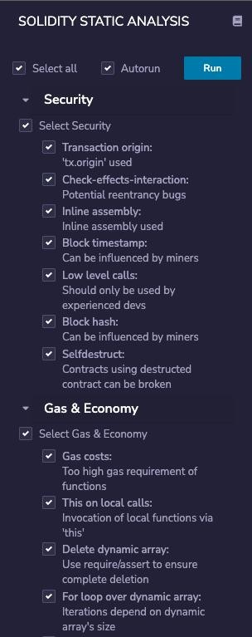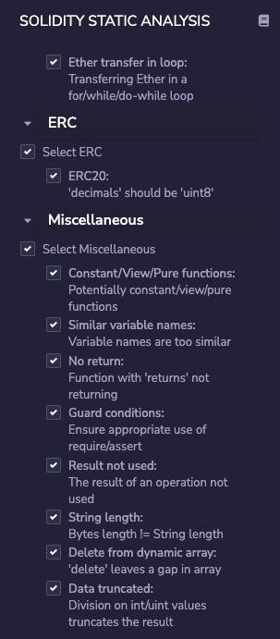

1. SOLIDITY UNIT TESTING

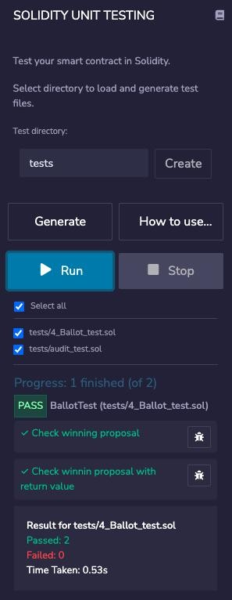

1. Call Graph

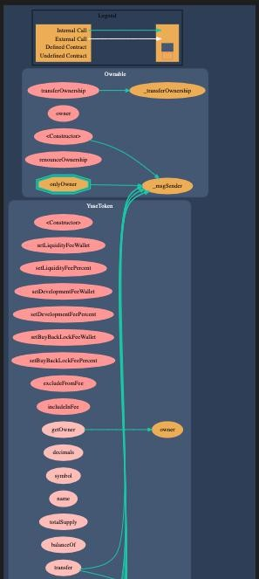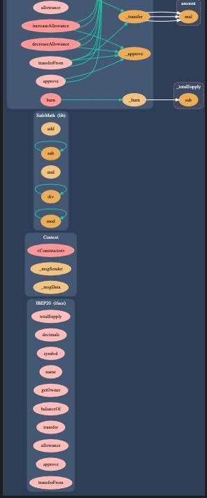

Unified Modeling Language (UML)

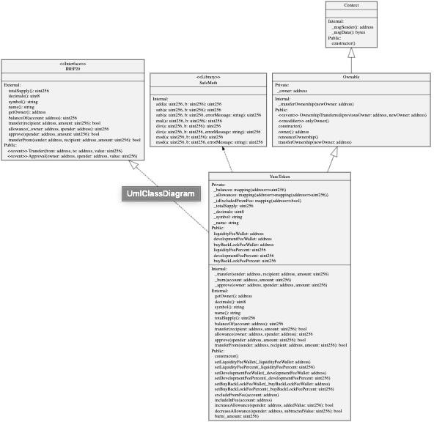

Functions Signature

Sighash | Function Signature

========================

|  |  |  |
| --- | --- | --- |
| 39509351 | => | increaseAllowance(address,uint256) |
| 18160ddd | => | totalSupply() |
| 313ce567 | => | decimals() |
| 95d89b41 | => | symbol() |
| 06fdde03 | => | name() |
| 893d20e8 | => | getOwner() |
| 70a08231 | => | balanceOf(address) |
| a9059cbb | => | transfer(address,uint256) |
| dd62ed3e | => | allowance(address,address) |
| 095ea7b3 | => | approve(address,uint256) |
| 23b872dd | => | transferFrom(address,address,uint256) |
| 119df25f | => | _msgSender() |
| 8b49d47e | => | _msgData() |
| 771602f7 | => | add(uint256,uint256) |
| b67d77c5 | => | sub(uint256,uint256) |
| e31bdc0a | => | sub(uint256,uint256,string) |
| c8a4ac9c | => | mul(uint256,uint256) |
| a391c15b | => | div(uint256,uint256) |
| b745d336 | => | div(uint256,uint256,string) |
| f43f523a | => | mod(uint256,uint256) |
| 71af23e8 | => | mod(uint256,uint256,string) |
| 8da5cb5b | => | owner() |
| 715018a6 | => | renounceOwnership() |
| f2fde38b | => | transferOwnership(address) |
| d29d44ee | => | _transferOwnership(address) |
| 686cbb28 | => | setLiquidityFeeWallet(address) |
| 8ee88c53 | => | setLiquidityFeePercent(uint256) |
| cd50e5bf | => | setDevelopmentFeeWallet(address) |
| 4680ff35 | => | setDevelopmentFeePercent(uint256) |
| eb1897c5 | => | setBuyBackLockFeeWallet(address) |
| c023c93f | => | setBuyBackLockFeePercent(uint256) |
| 437823ec | => | excludeFromFee(address) |
| ea2f0b37 | => | includeInFee(address) |
| a457c2d7 | => | decreaseAllowance(address,uint256) |
| 99a5d747 | => | calculateFee(uint256) |
| 30e0789e | => | _transfer(address,address,uint256) |
| 6161eb18 | => | _burn(address,uint256) |
| 104e81ff | => | _approve(address,address,uint256) |
| 42966c68 | => | burn(uint256) |

Automatic General Report

Files Description Table

| File Name | SHA-1 Hash |

| | |

| /Users/Downloads/sol/audit.sol | a4c60c13b0a09699192da9849eb48cfac02f1bbd |

Contracts Description Table

| Contract | Type | Bases | |

|

|: :|: :|: :|:

:|: :|

| └ | **Function Name** | **Visibility** | **Mutability** |

**Modifiers** |

||||||

| **IBEP20** | Interface | |||

| └ | totalSupply | External ❗ | |NO❗ |

| └ | decimals | External ❗ | |NO❗ |

| └ | symbol | External ❗ | |NO❗ |

| └ | name | External ❗ | |NO❗ |

| └ | getOwner | External ❗ | |NO❗ |

| └ | balanceOf | External ❗ | |NO❗ |

| └ | transfer | External ❗ | u |NO❗ |

| └ | allowance | External ❗ | |NO❗ |

| └ | approve | External ❗ | u |NO❗ |

| └ | transferFrom | External ❗ | u |NO❗ |

||||||

| **Context** | Implementation | |||

| └ | <Constructor> | Public ❗ | u |NO❗ |

| └ | _msgSender | Internal q | | |

| └ | _msgData | Internal q | | |

||||||

| **SafeMath** | Library | |||

| └ | add | Internal q | | |

| └ | sub | Internal q | | |

| └ | sub | Internal q | | |

| └ | mul | Internal q | | |

| └ | div | Internal q | | |

| └ | div | Internal q | | |

| └ | mod | Internal q | | |

| └ | mod | Internal q | | |

||||||

| **Ownable** | Implementation | Context |||

| └ | <Constructor> | Public ❗ | u |NO❗ |

| └ | owner | Public ❗ | |NO❗ |

| └ | renounceOwnership | Public ❗ | u | onlyOwner |

| └ | transferOwnership | Public ❗ | u | onlyOwner |

| └ | _transferOwnership | Internal q | u | |

||||||

|  |  |
| --- | --- |
| | | **Mr.Mint** | Implementation | IBEP20, Ownable ||| |
| | | └ | <Constructor> | Public ❗ | u |NO❗ | |
| | | └ | setLiquidityFeeWallet | Public ❗ | u | onlyOwner | |
| | | └ | setLiquidityFeePercent | Public ❗ | u | onlyOwner | |
| | | └ | setDevelopmentFeeWallet | Public ❗ | u | onlyOwner | |
| | | └ | setDevelopmentFeePercent | Public ❗ | u | onlyOwner | |
| | | └ | setBuyBackLockFeeWallet | Public ❗ | u | onlyOwner | |
| | | └ | setBuyBackLockFeePercent | Public ❗ | u | onlyOwner | |
| | | └ | excludeFromFee | Public ❗ | u | onlyOwner | |
| | | └ | includeInFee | Public ❗ | u | onlyOwner | |
| | | └ | getOwner | External ❗ | |NO❗ | |
| | | └ | decimals | External ❗ | |NO❗ | |
| | | └ | symbol | External ❗ | |NO❗ | |
| | | └ | name | External ❗ | |NO❗ | |
| | | └ | totalSupply | External ❗ | |NO❗ | |
| | | └ | balanceOf | External ❗ | |NO❗ | |
| | | └ | transfer | External ❗ | u |NO❗ | |
| | | └ | allowance | External ❗ | |NO❗ | |
| | | └ | approve | External ❗ | u |NO❗ | |
| | | └ | transferFrom | External ❗ | u |NO❗ | |

|  |  |  |  |  |  |  |  |  |
| --- | --- | --- | --- | --- | --- | --- | --- | --- |
| |  |  | | └  └  └ | |  |  | | increaseAllowance | Public ❗  decreaseAllowance | Public ❗  _transfer | Internal q | u | | | | |  | | u u | |NO❗  |NO❗ | |  | |
| | | └ | | | _burn | Internal q | u | | |  |  |  |  |  |
| | | └ | | | _approve | Internal q | u | | |  |  |  |  |  |

| └ | burn | Public ❗ | u |NO❗ | Legend

| Symbol | Meaning |

|: :| |

| u | Function can modify state |

| $ | Function is payable |

# Conclusion

The contracts are written systematically. Team found no critical issues. So, it is good to go for production.

Since possible test cases can be unlimited and developer level documentation (code flow diagram with function level description) not provided, for such an extensive smart contract protocol, we provide no such guarantee of future outcomes. We have used all the latest static tools and manual observations to cover maximum possible test cases to scan Everything.

Security state of the reviewed contract is **Secure**.



Well structured code.

High severity issues were not found. No Contract Ownership Renounced.

Disclaimer

This is a limited report on our findings based on our analysis, in accordance with good industry practice as of the date of this report, in relation to cybersecurity vulnerabilities and issues in the framework and algorithms based on smart contracts, the details of which are set out in this report. In order to get a full view of our analysis, it is crucial for you to read the full report. While we have done our best in conducting our analysis and producing this report, it is important to note that you should not rely on this report and cannot claim against the team on the basis of what it says or doesn’t say, or how team produced it, and it is important for you to conduct your own independent investigations before making any decisions. team go into more detail on this in the below disclaimer below – please make sure to read it in full.

By reading this report or any part of it, you agree to the terms of this disclaimer. If you do not agree to the terms, then please immediately cease reading this report, and delete and destroy any and all copies of this report downloaded and/or printed by you. This report is provided for information purposes only and on a non-reliance basis, and does not constitute investment advice. No one shall have any right to rely on the report or its contents, and Esp Softtech and its affiliates (including holding companies, shareholders, subsidiaries, employees, directors, officers and other representatives) (Esp Softtech) owe no duty of care towards you or any other person, nor does Esp Softtech make any warranty or representation to any person on the accuracy or completeness of the report. Esp Softtech’s does not have any control on admin wallets or funds involved The report is provided "as is", without any conditions, warranties or other terms of any kind except as set out in this disclaimer, and Esp Softtech hereby excludes all representations, warranties, conditions and other terms (including, without limitation, the warranties implied by law of satisfactory quality, fitness for purpose and the use of reasonable care and skill) which, but for this clause, might have effect in relation to the report. Except and only to the extent that it is prohibited by law, Esp Softtech hereby excludes all liability and responsibility, and neither you nor any other person shall have any claim against Esp Softtech, for any amount or kind of loss or damage that may result to you or any other person (including without limitation, any direct, indirect, special, punitive, consequential or pure economic loss or damages, or any loss of income, profits, goodwill, data, contracts, use of money, or business interruption, and whether in delict, tort (including without limitation negligence), contract, breach of statutory duty, misrepresentation (whether innocent or negligent) or otherwise under any claim of any nature whatsoever in any jurisdiction) in any way arising from or connected with this report and the use, inability to use or the results of use of this report, and any reliance on this report. Esp Softtech involved just to audit smart contract. The analysis of the security is purely based on the smart contracts alone. No applications or operations were reviewed for security. No product code has been reviewed.